Big Picture

**Why is the River Irwell so important to our area ?**

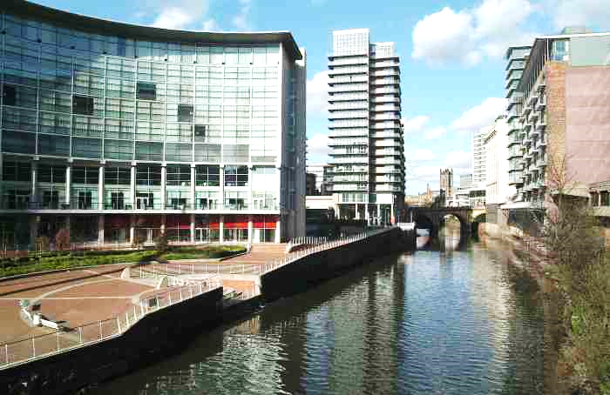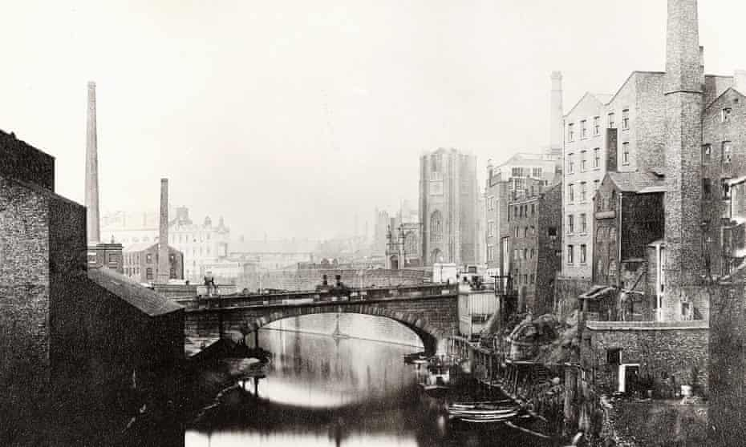

* Where is the River Irwell ?
* What other famous European cities are situated by a river ?
* Why were rivers important to the lives of the people who lived near them in the past?
* What is the River Irwell used for today ?

**Question I would like at ask :**

**skills we will use:**

reading

map reading

discussing

comparing

investigating

presenting

**Vocabulary we will use:**

tributary

confluence

canal

settlement

industry

leisure

trade

migrants

manmade

European