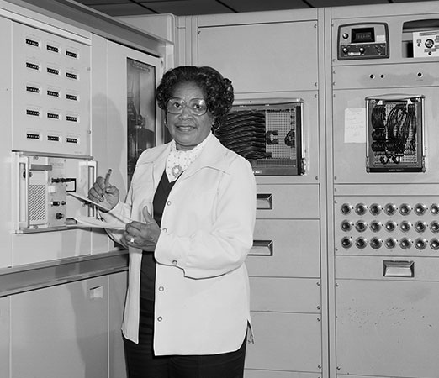
MARY JACKSON

Mary Jackson was an American mathematician and engineer. She became the first African American female engineer at the National Aeronautics and Space Administration (NASA). Jackson was also known for her volunteer work at NASA and in her community.

EARLY LIFE
Mary Winston was born on April 9, 1921, in Hampton, Virginia. After graduating from high school with highest honors, she earned a dual degree in mathematics and physical science at the Hampton Institute in 1942. She worked as a math teacher in Maryland for a year before she returned to Hampton. She married Levi Jackson.

CAREER
In 1951 Jackson began work at the West Area Computing unit at the National Advisory Committee for Aeronautics (NACA) in Hampton. The unit was made up of African American female mathematicians. Known as the West Computers for their mathematical computations, these women provided data that was essential to the success of the U.S. space program.
The West Computers were segregated from white employees. They were forced to use separate bathrooms and dining facilities. In 1958 NACA became NASA, and all segregated facilities were closed.
In 1953 Jackson moved out of the West Area Computing unit. She conducted experiments with engineer Kazimierz Czarnecki.
Czarnecki suggested that Jackson enter a training program that would allow her to become an engineer. She had to obtain special permission to take classes with white students. At the time, Virginia’s schools were segregated. Jackson did receive permission, however, and she completed the necessary courses. In 1958 Jackson became NASA’s first Black female engineer.
Jackson worked as an engineer until 1979, when she became the manager of the women’s program at NASA. She worked hard to improve the opportunities for all women in NASA. She retired in 1985.

