tributary | a stream feeding a larger stream or a lake.
confluence | when two or more flowing bodies of water join together to form a single channel
canal | a human-made waterway that allows boats and ships to pass from one body of water to another.
settlement | is a place where people live. Settlements can be as small as a single house in a remote area or as a large as a mega city
industry | activity concerned with the processing of raw materials and manufacture of goods in factories.
leisure | Free time when you are not in work, education or carrying out essential domestic activities
trade | Buying and selling things
migrants | A person who moves from one permanent home to another; a person who moves regularly in order to find work
manmade | something that was created by humans, not made by God or nature
European | A word which describes a person, object, idea etc from any country which is in the continent of Europe.
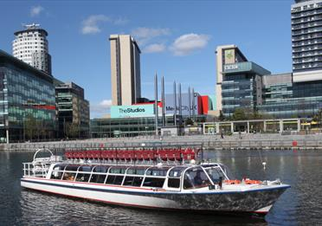
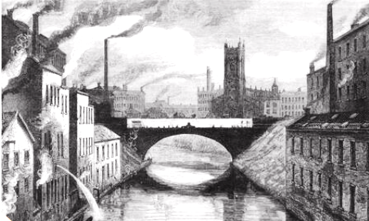
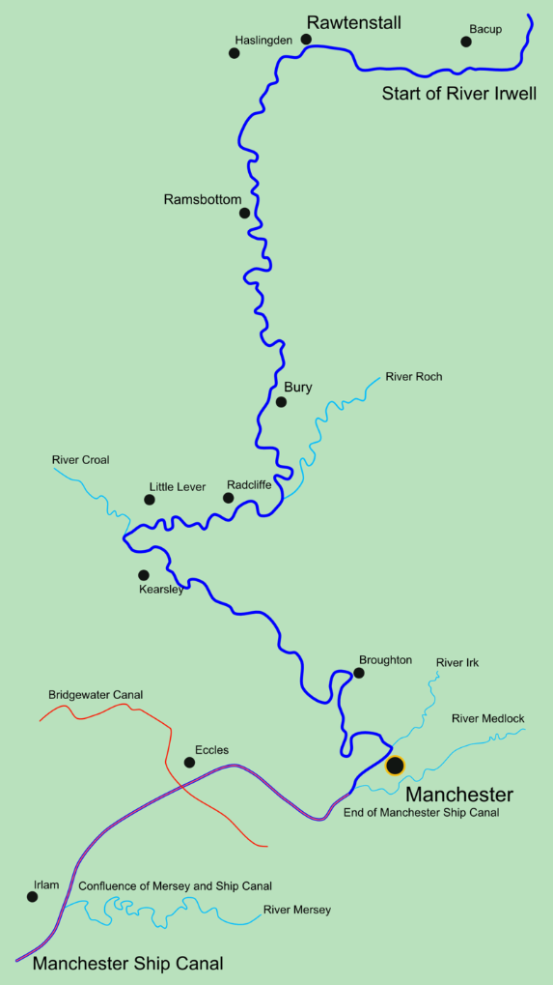
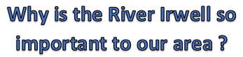
Vocabulary
Big Ideas
Manchester Ship Canal opened in 1894. The canal turned Manchester and Salford into a major inland seaport and led to the development of Trafford Park which became the largest industrial estate in Europe
Today, the Irwell is used for recreational activities, such as pleasure cruising, rowing, racing, swimming and fishing.
The River Irwell was badly polluted by factories and chemicals during the Industrial Revolution.

The River Irwell is a a river in the North west of England. It starts north of Bacup and flows southwards for 39 miles ( 63km) to meet the River Mersey near Irlam.
The Irwell marks the boundary between Manchester and Salford, and the lower part of the Irwell was made to form part of the Manchester Ship Canal.
Why is the River Irwell so important to our area ?

