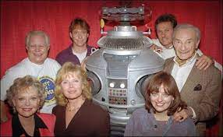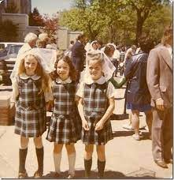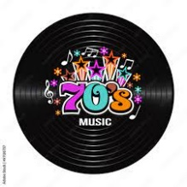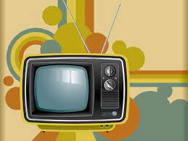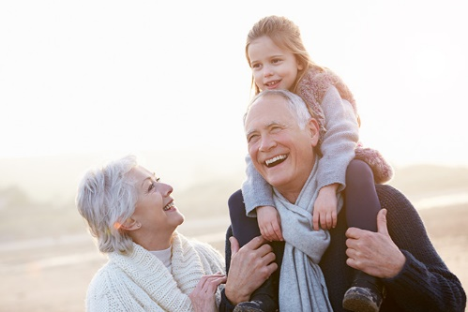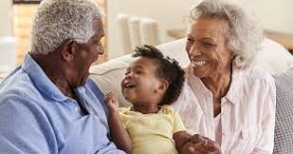

Skills we will use on our learning journey:

reading

sequencing

reasoning

research

explaining

**Questions we will investigate on**

**our learning journey:**

* What was grandma and grandad’s day like at school?
* What sort of phones and T.V programmes did they have?
* What type of clothes did they wear when they were your age?
* What toys did they play with?
* Were the changes for the better?

Vocabulary we will use on our

learning journey:

new

long time ago

old

before

after

grandparents

present

**What has changed since my grandparents were young?**

?

Question I would like to ask:

**BIG PICTURE**