Big Ideas- What would a journey through your body look like?
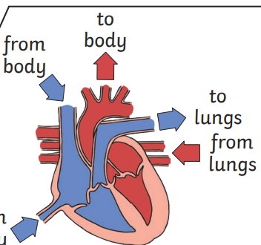

 | Key Vocabulary
Circulatory system | A system which includes the heart, veins, arteries and blood transporting substances around the body.
Heart | An organ which constantly pumps blood around the circulatory system.
Blood vessels | The tube-like structures that carry blood through the tissues and organs. Veins, arteries and capillaries are the three types of blood vessels
Oxgenated blood | Oxygenated blood has more oxygen. It is pumped from the heart to the rest of the body.
Deoxgenated blood | Deoxygenated blood is blood where most of the oxygen has already been transferred to the rest of the body
Drug | A substance containing natural or man-made chemicals that has an effect on your body when it enters your system.

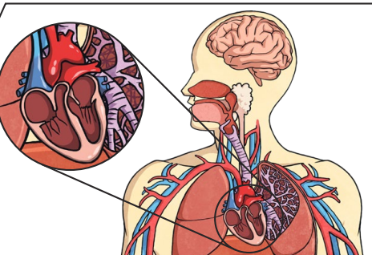

Important facts to know:
- Capillaries are the smallest blood vessels in the body and it is here that the exchange of water, nutrients, oxygen and carbon dioxide takes place.
- Blood transports: gases (mostly oxygen and carbon dioxide), nutrients (including water) and waste products.
- Drugs, alcohol and smoking have negative effects on the body.
- A healthy diet involves eating the right types of nutrients in the right amounts.
- Red blood cells carry oxygen through your body.
- Platelets help you stop bleeding when you get hurt.
- White blood cells fight infection when you’re sick.
- Regular exercise: strengthens muscles including the heart muscle, improves circulation, increases the amount of oxygen around the body, releases brain chemicals which help you feel calm and relaxed and helps you sleep.

