Big Ideas- How and why do Christians read the Bible?
Christian values
Wisdom | the quality of having experience, knowledge, and good judgement; the quality of being wise
Faith | complete trust or confidence in someone or something.
Key vocabulary | Definition
sacred | Very holy and special.
Christians | People who follow the religion of Christianity.
revelation | The Christian belief that God reveals himself to people through words or actions.
Bible | The holy book followed by Christians
psalms | Poems and songs recorded in the Bible.
parables | A story told by Jesus, to teach a particular lesson.
proverbs | Wise sayings recorded in the Bible.
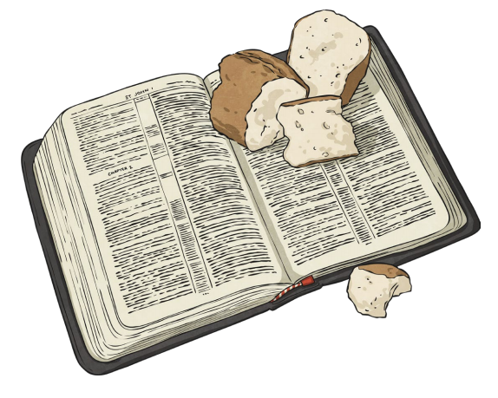
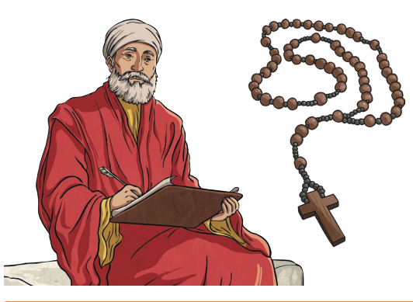
Old Testament | The Old Testament contains stories and writings from before the birth of Jesus. The first five books of the Old Testament (the books of Moses) are also sacred texts to Jewish people.
New Testament | The New Testament is about the life and teachings of Jesus and his followers. The final book in the Bible is a prophecy about how Jesus will return one day.

