**How different will you be when you are as old as your grandparents?**

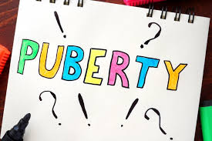

**Questions we will explore:**

* How do humans change as they get older? Can you accurately sketch yourself and a grandparent?
* What can you do now that you couldn’t do as a baby?
* What are the important things we should do to keep fit and healthy?
* What do we understand by the term puberty?
* What is the life expectancy of different animals?

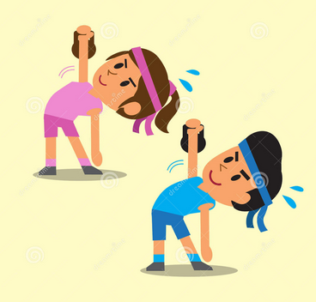

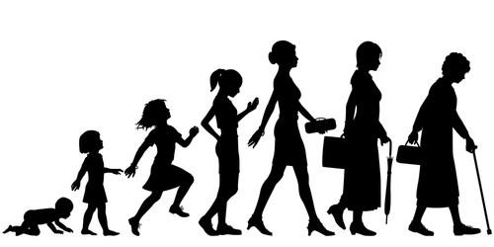

Skills I will use:

* Maths- data handling
* Research
* Reflection and evaluation
* Use of IT.
* Art-sketching

Questions I would like to ask...

Vocabulary we will use:

Growth

Puberty

Life expectancy

Timeline

Reproduce

Baby

Child

Adolescence

Adult

Old age