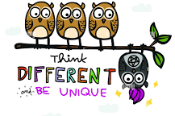
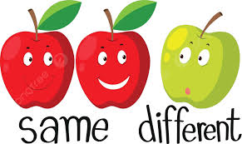

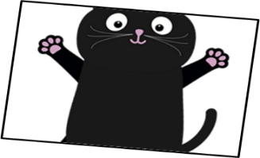

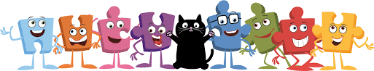
BIG PICTURE
Vocabulary we will use:
similar
different
bully
friend
unique
special
class
inclusive
Questions we will investigate on our learning journey:
- Can I identify similarities between people in my class?
- Can I identify differences between people in my class?
- Can I tell you what bullying is?
- Do I know some people that I could talk to if I was feeling unhappy or being bullied?
- Do I know how to make new friends?
- Do I understand that being different from my friends makes me unique and special?
Skills we will use on our learning journey:

Listening
Sharing
Reflecting
Explaining
Understanding

Question I would like to ask:

Celebrating Difference

