Why are mountains MIGHTY ?

Big Picture

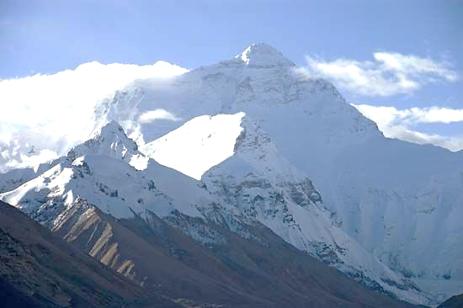

* What are tectonic plates and where are they ?
* How are some mountains formed ?
* Where are some of the World’s mountain ranges ?
* How can we recognise mountains on a map ?
* What is it like at the top of a mountain ?

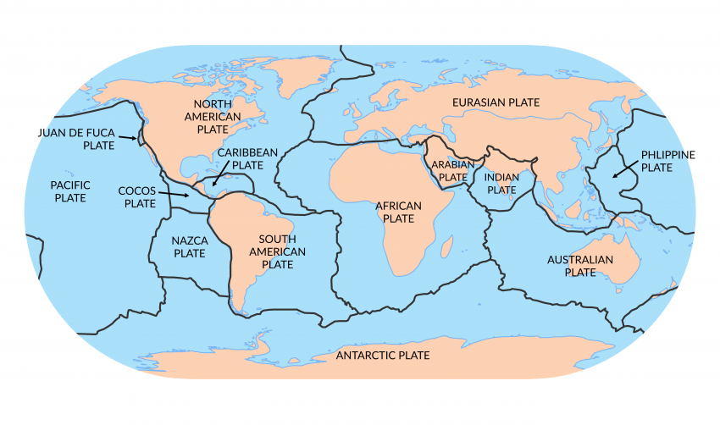

Vocabulary we will use :

tectonic plates

layers

crust

core

fault lines

summit

altitude

contour lines

topography

range

valley

erode

Question I would like to ask:

