Big Ideas- All About Me!
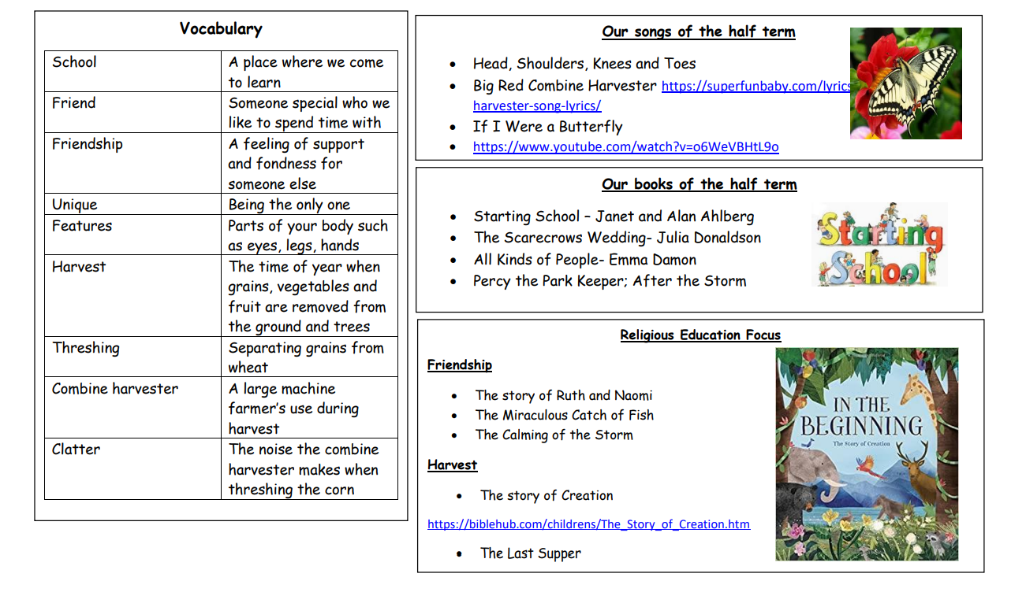

Big Ideas- All About Me!

