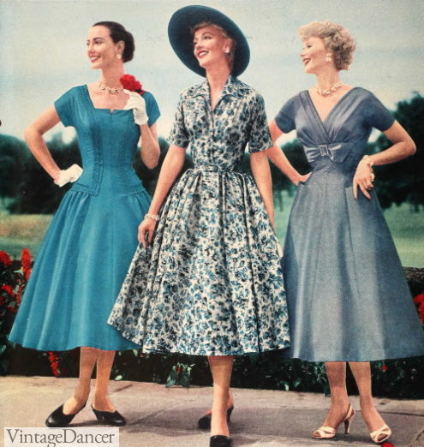

**Big Picture**

**What was it like when the Queen came to the throne in 1953?**

**Questions we will explore:**

1. What is a monarch?
2. What qualities does someone need to be a good monarch?
3. What is a coronation?
4. What happened in 1953?
5. Can we design our own coronation flags?
6. What was life like in the 1950s? - Home and Food
7. What was life like in the 1950s? - School and Toys
8. What was life like in the 1950s? - Fashion and Music.

Vocabulary I will use:

* Monarch
* Queen
* Crown
* Reign
* Royal Family
* Differences
* Inventions
* Lifestyle

Skills I will use:

* Research
* Exploration
* Investigating
* Comparison
* Reflection
* Creativity
* Observing
* Looking at artefacts

Questions we would like to ask: