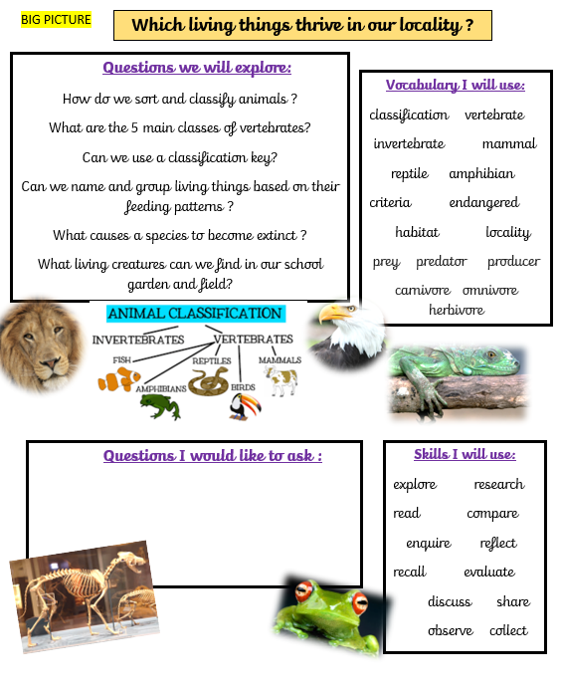
How are living things grouped ?
- How do we sort and classify animals ?
- Can we sort animals based on their feeding pattern ?
- Can we use a classification key ?
- How can human behaviour be a danger to other living things ?

