Who were the Mayans and what have we learnt from them?

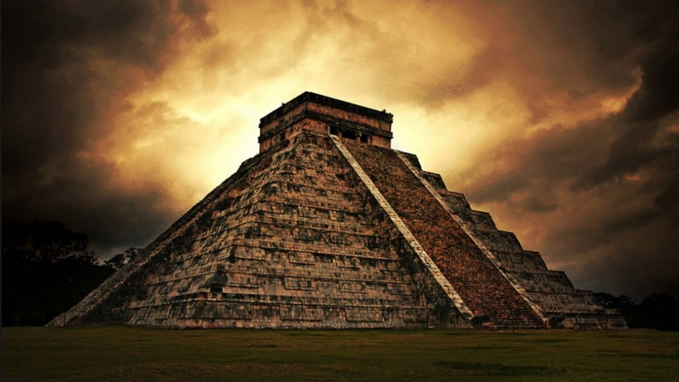
Questions we will explore;
- Who were the Mayans and where did they live?
- What evidence do we have that the Mayans were an advanced civilization?
- What have the Mayan civilization in common with space travel?
- What can we learn from the way they built their pyramids?
- What do we know of the rituals carried out by the Mayan civilization?
- Why was the Sun an important feature in Mayan life?
- What caused the Mayan Civilization to disappear?
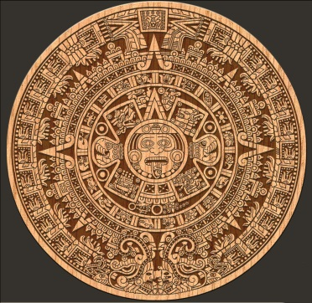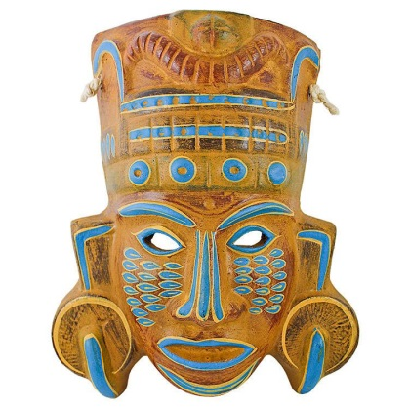
Vocabulary we will use:
Timeline, chronological, civilizations, architecture, rituals,
Questions I would like to ask?
Skills we will use:
- Research including ICT, market research
- Debate and discussion
- Reflection
- DT- use of tools
- Reading and evaluating
- Atlas work
- Persuasive writing

