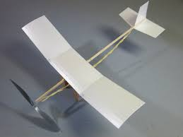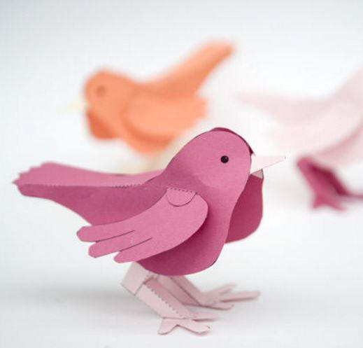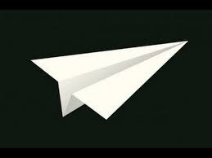

DT Day 2021

How far will our model bird fly?

Class 4

Name:

**How far will our model bird fly**?

**Questions we will explore:**

* How many designs for paper planes can we research and which fly the furthest?
* What birds might we find in the Amazon?
* What materials will be best to use and why?
* How will we join our materials and still ensure our plane is light and aerodynamic?
* What modifications will improve the performance of our plane?
* How will we test our designs?



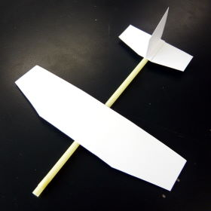



**Questions I would like to ask** ...



**Vocabulary**

Research, measure, child proof, materials, safety, textiles, planning, evaluate, sewing

**Skills we will use;**

* Developing, planning and communicating ideas (a range of ideas, produced a detailed plan, suggest alternatives)
* Working with tools, equipment and materials to produce a quality product (explain why their finished product works, use equipment safely, explain their products appeal)
* Evaluate the process and product (make improvements, evaluate against a criteria)

LO: To assess prior learning



Which paper planes designs worked the best?

* Draw each design in the box below:

|  |  |
| --- | --- |
| *A* | *B* |
| *C* | *D* |

**LO: Which design flew the furthest?**

An experiment to test the impact of plane design.

Apparatus:

_______________________

_______________________

_______________________

_______________________

_______________________

**Method:**

________________________________________________________________________________________________________________________________________________________________________________________________________________________________________________________________________________________________________________________________________________

**Prediction**

________________________________________________________________________________________________________________________________________________________________________

**Results:**

|  |  |
| --- | --- |
| Design | Distance flew |
|  |  |
|  |  |
|  |  |
|  |  |

**Conclusion**

________________________________________________________________________________________________________________________________________________________________________

LO: To research birds found in the Amazon Rainforest

*What birds might we find in the Amazon Rainforest?*

*Choose one and complete a detailed sketch below:*

Challenge: Research some facts about this bird.

Which materials will we use and what joining techniques?

Is our product finished to a high standard and how could it be improved?

My improvements:

**The test of our design**

We are going to test our design against different criteria and score it out of 10:

|  |  |
| --- | --- |
| Criteria | Score |
| Appearance | EBI |
| Aerodynamic (distance travelled) | EBI |
| Ease to make/ level of difficulty | EBI |
| Teamwork | EBI |

**Retention quiz**

|  |  |  |  |
| --- | --- | --- | --- |
| Which is the name of a paper plane design? | a. coaster | b. spider | c. fly |
| Tick the names of birds found in the Amazon. | a. Hyacinth macaws | b. Scarlet Macaw | c. Penguins |
| What does aerodynamic mean? | a. It is the**way land moves around things**. | b. It is the**way water moves around things**. | c. It is the**way air moves around things**. |
| What is a fait test important? | a. A **test**that controls all but one variable when attempting to answer a scientific question | b. A **test**that controls all variables when attempting to answer a scientific question | c. A **test**that controls two variables when attempting to answer a scientific question |
| Why do we evaluate? | a. To assess something against a criterion. | b. To design something against a criterion. | c. To plan something against a criterion. |

**How far will our model bird fly?**



**Topic Feedback:**

|  |  |
| --- | --- |
| * How many designs for paper planes can we research and which fly the furthest? | Image result for smiley faceRelated imageRelated image |
| * What birds might we find in the Amazon? | Image result for smiley faceRelated imageRelated image |
| * What materials will be best to use and why? | Image result for smiley faceRelated imageRelated image |
| * How will we join our materials and still ensure our plane is light and aerodynamic? | Image result for smiley faceRelated imageRelated image |
| * What modifications will improve the performance of our plane? | Image result for smiley faceRelated imageRelated image |
| * How will we test our designs? | Image result for smiley faceRelated imageRelated image |

What I liked about the topic:

What I would do to make it even better: