Key Words
Similar | When we are like something or someone.
Different | When we are not like something or someone.
Bully | Someone why is mean all the time on purpose.
Friend | Someone we rely on and enjoy being with.
Unique | When our differences make us special.
Inclusive | To accept everybody regardless of who they are.
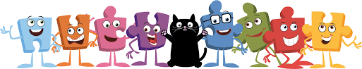
BIG IDEAS
Celebrating Difference

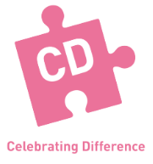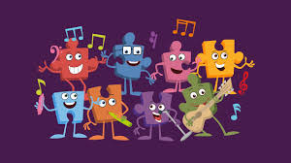
I can identify similarities between people in my class.

I can tell you some ways that I am different from my friends.

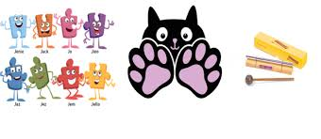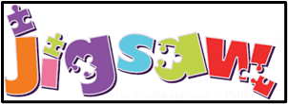
I can tell you what bullying is.

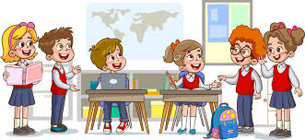

I know how to make new friends.

I know some people I could talk to if I was unhappy or being bullied.

I understand that difference make us all special and unique.

