**Can you feel the force?**

**Questions we will explore:**

* What is friction and how does it affect moving objects?
* Why will a car always move faster than a boat?
* What is gravity and why is Isaac Newton linked to it?
* Can you design and make a parachute to help you understand more about air resistance?
* How do builders get heavy items onto the top of skyscrapers?
* What helps you to climb hills on your bicycle?

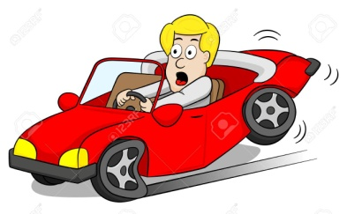

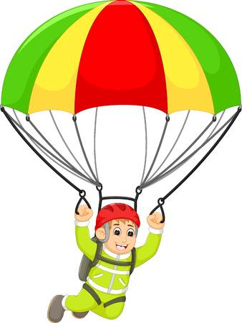

Questions I would like to ask...

Vocabulary we will use:

Air resistance

Attract

Earth

Fall

Force

Forcemeter

Friction

Gears

Gravity

Levers

Magnets

Magnetic force

Mechanism

Moving surfaces

Newton

Newtonmeter

Pulley

Transfer

Water resistance

Skills I will use:

* Observation
* Research
* Reflection and evaluation
* Use of IT.
* Art
* Presentation via powerpoint
* Fair Test/Experiments.

