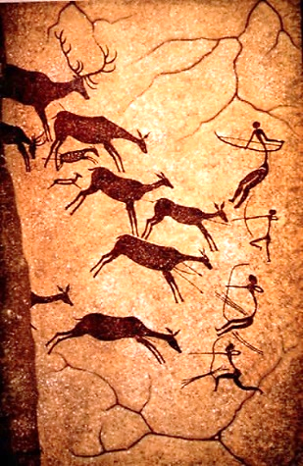
Who first lived in Britain ?
Big Picture
When was the Stone Age?
Why are archaeologists valuable in helping us find out about the people of the past?

How did the early Britons make shelters?

Would the early Britons have visited a supermarket for their food?

How did the people of the Stone Age communicate?
What dangers did they face?

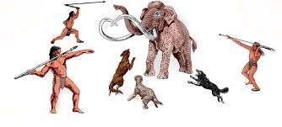
How did the early Britons develop between the Palaeolithic and Neolithic eras?

What Ages came after the Stone Age ?
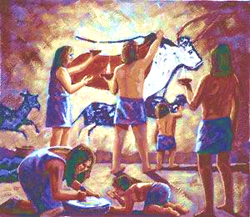

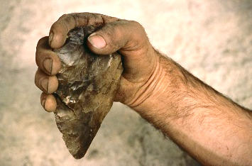

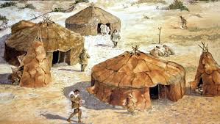
Skills we will use
investigate
observe
question
compare
reflect
read
write
discuss
empathise

Vocabulary
settlement
hunter-gatherer
nomadic
wattle and daub
palaeolithic
neolithic
artefact
Britons

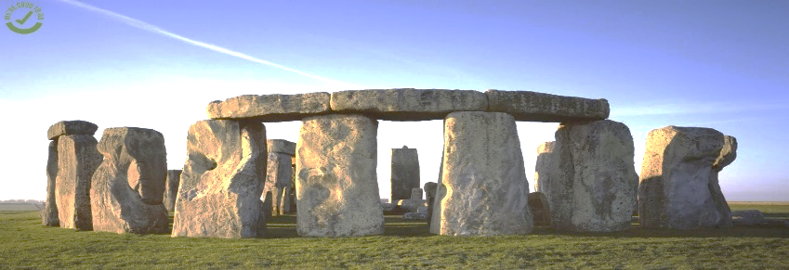
Question I would like to ask :

