**Big Ideas and Big Picture- How do I know my way around?**

**Skills I will use:**

* **Observing**
* **Exploring**
* **Learning**
* **Drawing**
* **Sharing**
* **Discussing**
* **Imagining**

**What do we want to know?**

* **How will we get to the library?**
* **What journey does the Gruffalo go on?**
* **How do we get to school?**
* **Is a holiday a journey?**

**A Journey We are going to take?**

* **To the library!**

**Questions We Will Explore**

* **What is a journey?**
* **What journeys did Jesus go on?**
* **What journey will we do?**
* **Where will we go?**

**Religious Education Focus**

**Stories Jesus Heard**

* **The story of Moses and the Reeds**
* **Ruth and Naomi**
* **Noah’s Ark**
* **Jonah and the Whale**

**Our Songs of the Half Term**

* **We are family-Sister Sledge**
* **Wind the Bobbin Up**
* **The Lord is My Shepherd**

|  |  |
| --- | --- |
| **Vocabulary** | |
| **Journey** | **To go somewhere** |
| **Adventure** | **To have a fun journey!** |
| **Left** | **Directional language** |
| **Right** | **Directional language** |
| **North** | **Directional language** |
| **South** | **Directional language** |
| **East** | **Directional language** |
| **West** | **Directional language** |

**Our Books of the Half Term**

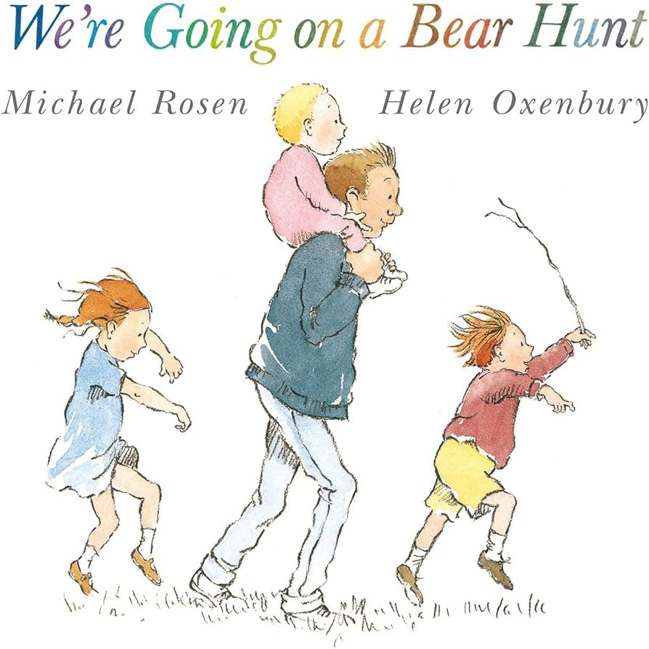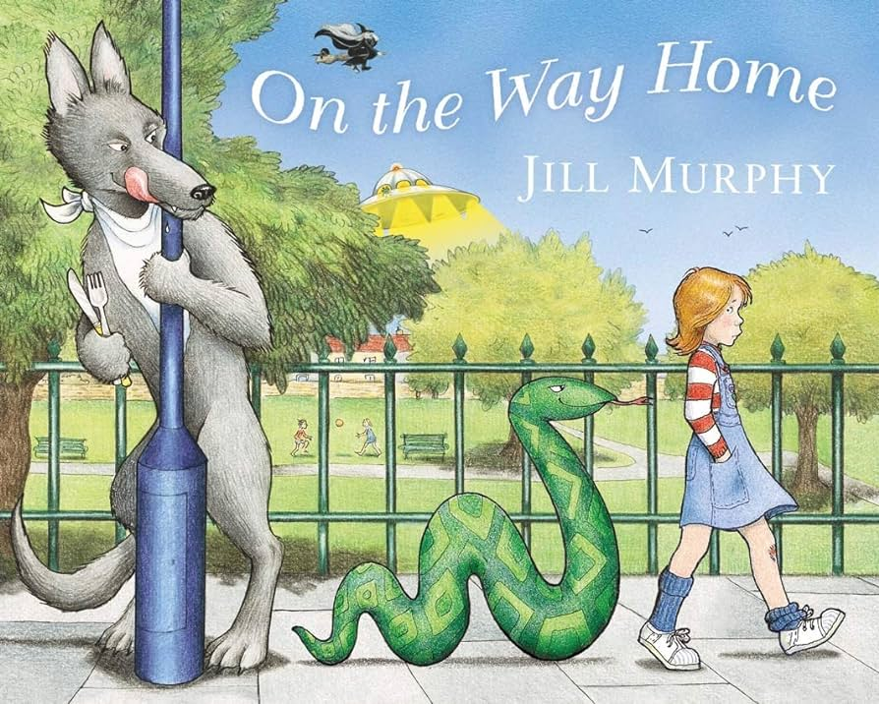 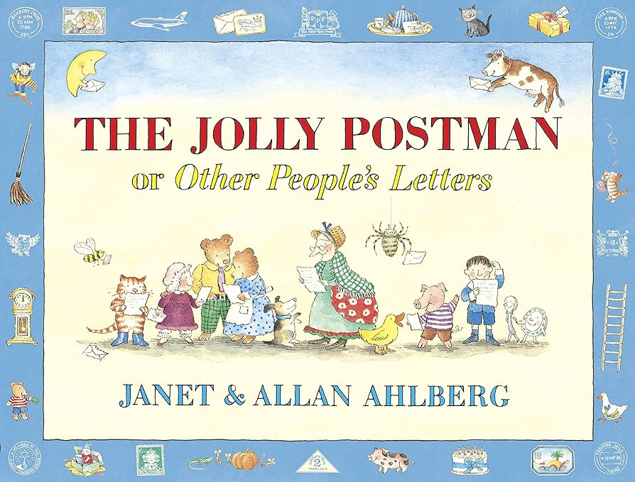 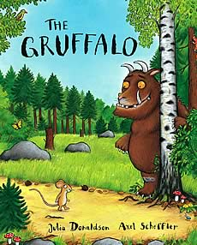

**Big Ideas and Big Picture- Stories Jesus Heard**

**Skills I will use:**

* **Observing**
* **Exploring**
* **Learning**
* **Drawing**
* **Sharing**
* **Discussing**
* **Imagining**

**What do we want to know?**

* **Who told Jesus the stories?**
* **How do we know about them?**
* **Who made the stories up?**

**Links to Journeys.**

* **Moses’ journey down the river Nile.**

**Questions We Will Explore**

* **How did Moses get there safely?**
* **Why was Jonah being silly with the whale?**

**Our Songs of the Half Term**

* **We are family-Sister Sledge**
* **Wind the Bobbin Up**
* **The Lord is My Shepherd**

|  |  |
| --- | --- |
| **Vocabulary** | |
| **Moses** | **A very important person in the Bible.** |
| **Ruth** | **A person in a story who is a good friend.** |
| **Noah** | **A famous person in the bible who has an ark.** |
| **Jonah** | **The man who was eaten by the whale.** |

**Our Books of the Half Term**

* **The story of Moses and the Reeds**
* **Ruth and Naomi**
* **Noah’s Ark**
* **Jonah and the Whale**