Big Ideas
Subject Specific vocabulary |  | 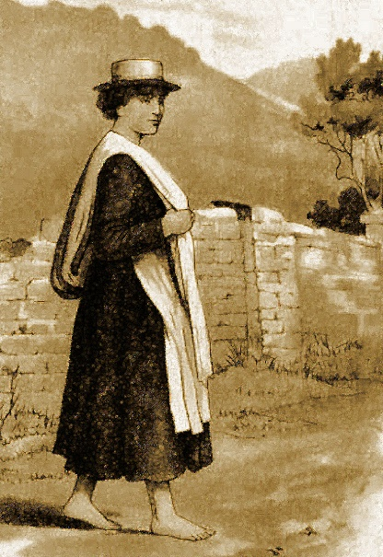  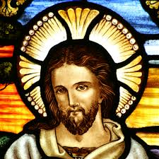  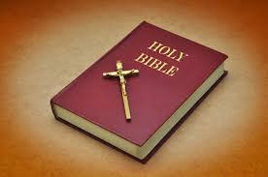  Mary Jones (16 December 1784 – 28 December 1864) was a Welsh girl who, at the age of fifteen, walked twenty-six miles barefoot across the countryside to buy a copy of the Welsh Bible from Thomas Charles because she did not have one. inspired the founding of the British and Foreign Bible Society.
Bible | The holy book that Christians worship from.
Old Testament | The first half of the Bible, full of stories about God from BEFORE Jesus was born. There are 39 stories.
New Testament | The second half of the Bible, full of stories from AFTER Jesus was born. There are 27 stories in this section.
Holy | Sacred to God
Gospel | The teachings of God
Word of God | The message God is giving through his Gospels.

