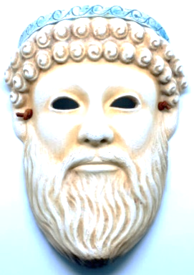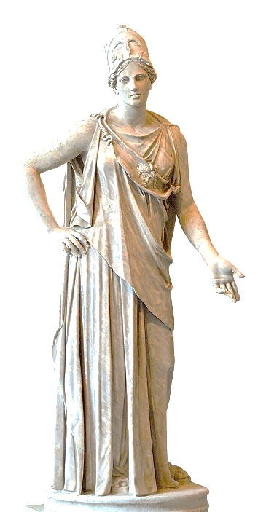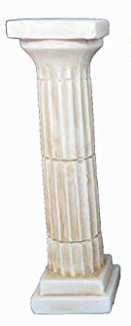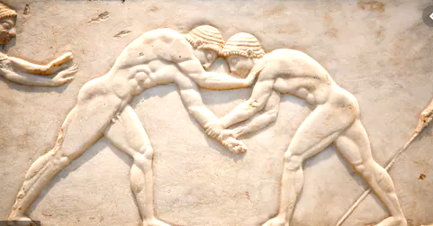

BIG PICTURE

Why are we still talking about Ancient Greece ?

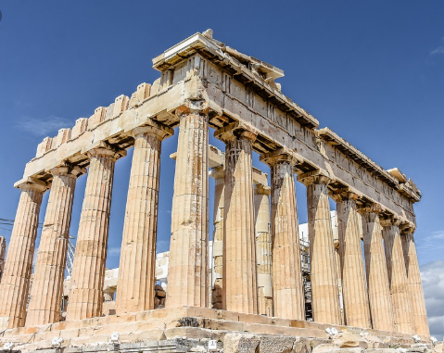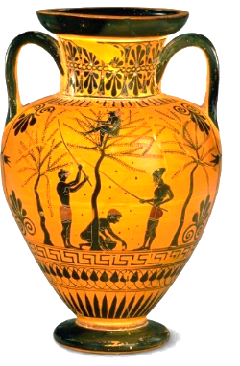

**Questions we will investigate:**

* When were the Ancient Greeks around ?

and can we place them on a time line ?

* How do we know what life was like in Ancient Greece ?
* Who was in charge in Ancient Greece ?
* Can we compare Athens and Sparta ?
* What can we find out about Alexander the Great ?
* Can we thank the Ancient Greeks for anything in our lives today ? *( theatre, architecture, democracy, Olympics, language)*

**Disciplinary skills we will use:**

Chronology

Using sources as evidence

Similarities and differences

Cause and consequence

Interpretation

Continuity and change

**Question I would like to ask:**

**Vocabulary we will use:**

**Empire**

**Conquest**

**civilization**

**democracy**

chronological

BC AD

artefacts

primary sources

evidence

archaeologist

peninsula

city states

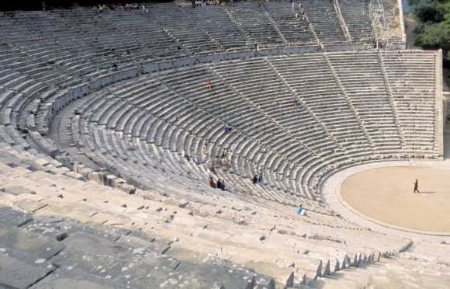

Historians believe the Ancient Greeks lived from around **2,500 years ago.**

BIG IDEAS

The Ancient Greeks invented the **theatre** – they performed comedies and tragedies in open air theatres. Some of these can still be seen in Greece today. The **architecture** and **building style** of the Ancient Greeks is still copied today .

Why are we still talking about Ancient Greece ?

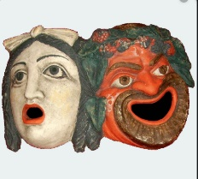



Every 4 years, an Olympic Games is held in a different city. Countries from all over the world take part in many sports. **The very first Olympics** was held in Ancient Greece in **776BC in Olympia**.

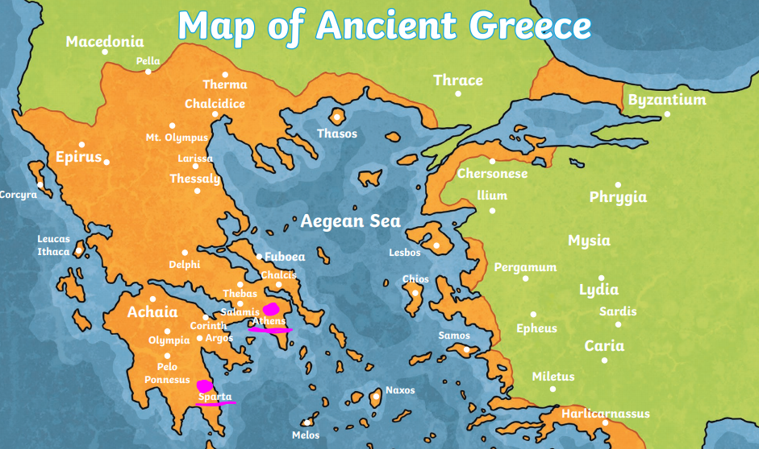

Greece is a country which sticks out into the sea. It is **surrounded by the Mediterranean Sea**. It is a **peninsula.**

**Democracy** was first used in Ancient Greek times : the idea that citizens had equal opportunities and a say in who ruled them.

**Mediterranean Sea**

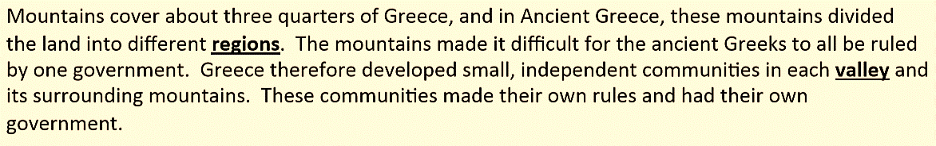

They believed and worshipped **many gods and goddesses** .

The brothers **Zeus, Hades, and Poseidon** were the **most important gods** of all.

**Alexander the Great** was the king of Macedonia or Ancient Greece. He is considered one of the greatest military commanders in history. He had one of the largest empires in history ! He was 32 years old when he died.

**Athens** and **Sparta** were the two most powerful city states in Greece and had many battles. Both had strong armies.