Big Picture

**What were the people who lived in our town like**

**150 years ago? (Victorians)**

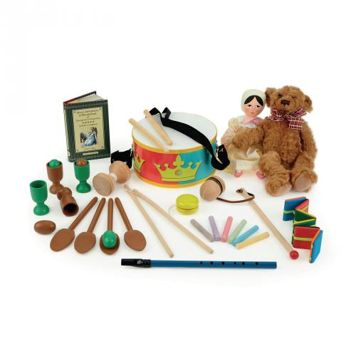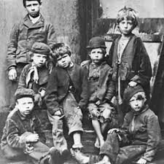

**Questions we will explore:**

* How did Queen Victoria define the Victorian era?
* Can we identify some amazing inventions from the Victorian era?
* Can we describe what homes would have been like during the Victorian era?
* What would it have been like to have gone to school as a Victorian child?
* What did people do for fun during the Victorian era?
* What was life like for poor people during the Victorian era?

**Questions I would like to ask…**

**Vocabulary I will use….**

* Victorian era
* Industry / factories
* Workhouse
* Inventions
* Servants
* Monarchy
* Governess

**Skills I will use….**

* Research
* Observation
* Explore artifacts
* Reflection and evaluation
* Role play
* Design and creation
* Empathy and comparison