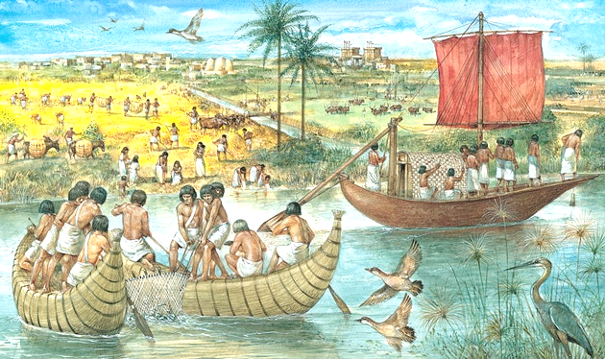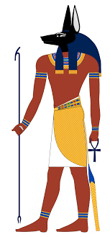

**Why pyramids were built?**

Egypt's pharaohs expected to become gods in the afterlife. **To prepare for the next world** they built temples to the gods and massive pyramid tombs for themselves—filled with all the things each ruler would for the next life.

**Would I like to have been an Ancient Egyptian?**