Big Picture

**Why did the Titanic sink?**

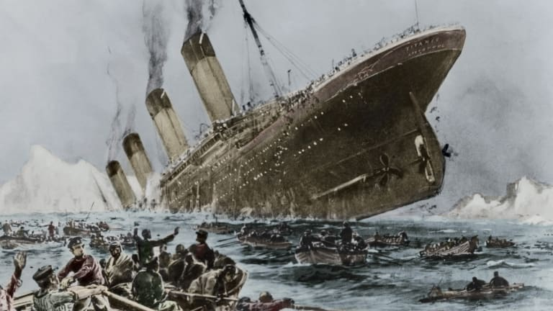

**Questions we will explore:**

* Why was the Titanic considered such an important ship?
* What was it like being a first-, second- or third-class passenger onboard the Titanic?
* Who were some of the people onboard the Titanic?
* Can we create a detailed timeline showing the events that led to the Titanic sinking?
* Who do you think is to blame for the sinking of the Titanic?

**Questions I would like to ask…**

**Vocabulary I will use….**

* Unsinkable
* Atlantic
* Voyage
* Disaster
* Iceberg
* Collision
* Survivors

**Skills I will use….**

* Research
* Observation
* Explore artifacts
* Reflection and evaluation
* Role play
* Design and creation
* Empathy and comparison