**Could you be the next CSI investigator?**

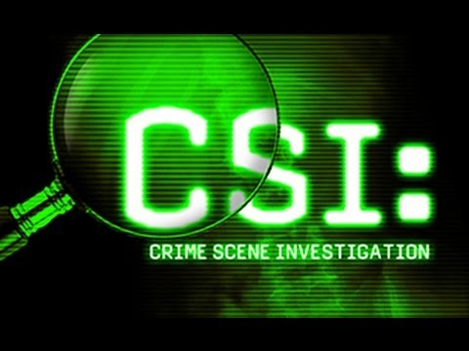

**Questions we will explore:**

*Can you think of five materials that can be changed and reversed and five cannot?

*How have scientists made use of changes to create materials that make our lives easier?

*Which materials dissolve and evaporate and why can this sometimes be an important quality in those materials?

*How are reversible and irreversible changes important to forensic scientist?

*What is bicarbonate of soda and what impact does it have on different materials?

*Using finger prints as well as hand and foot prints, can you create an interesting piece of art work that has interesting design features?

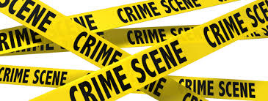

Vocabulary we will use:

Properties

Changes

Materials

Reversible

Irreversible

Solubility

Transparency

Conductivity

Magnetism

Substance

Filtering

Sieving

Solid

Liquid

Gases

Forensics

Questions I would like to ask...

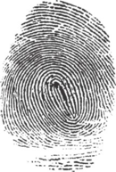

Skills I will use:

* Observation
* Research
* Reflection and evaluation
* Use of IT.
* Art
* Presentation via powerpoint
* Fair Test/Experiments.