Big Ideas- How do our celebrations reflect the true meaning of Christmas?

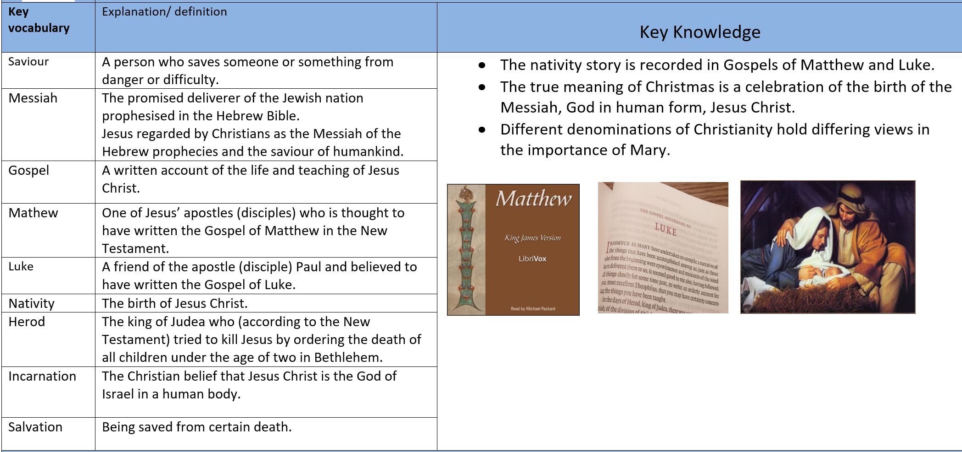
Christian values:
Humility | Humility is the quality of having a modest or low view of one's importance. | Hope | a feeling of expectation and desire for a particular thing to happen.

