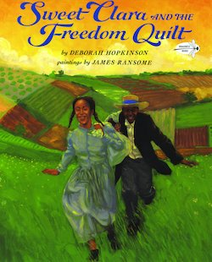
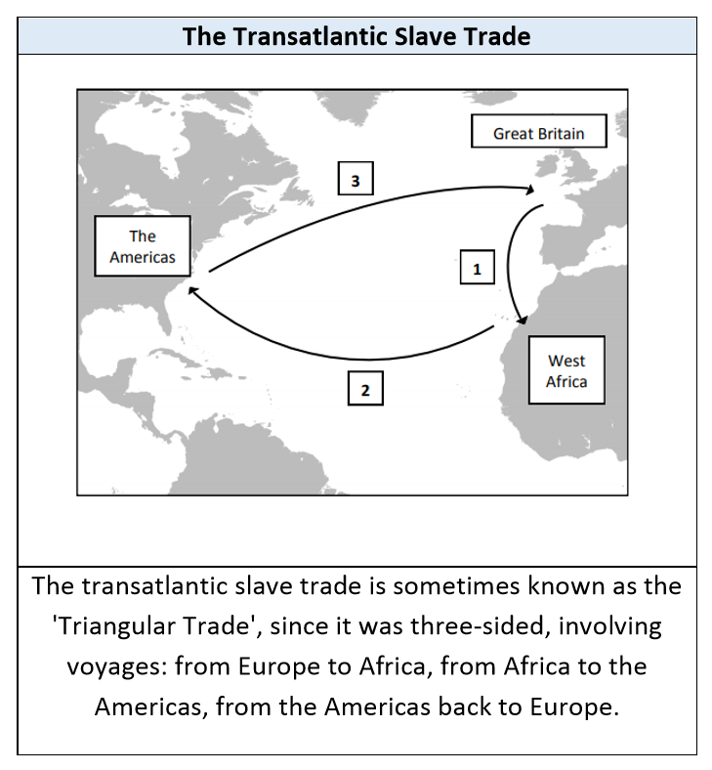
The Big Ideas- Why should the world be ashamed of slavery?
Transatlantic Slave Trade | Responsible for the forced migration of between 12 - 15 million people from Africa to the Western Hemisphere from the middle of the 15th century to the end of the 19th century
Slave | A slave is a human being classed as property, who is owned by another person and who is forced to work for nothing.
Atlantic passage | Sometimes known as the ‘middle passage’, refers to the part of the trade where Africans, densely packed onto ships, were transported across the Atlantic to the West Indies
Plantation | a usually large farm or estate, especially in a tropical or semitropical country, on which cotton, tobacco, coffee, sugarcane, or the like is grown.
Abolitionist | An abolitionist was someone who wanted to end slavery.
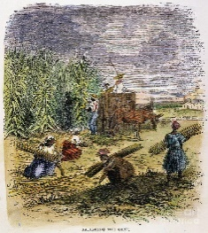 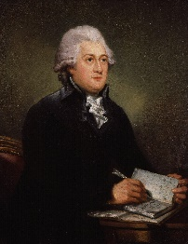 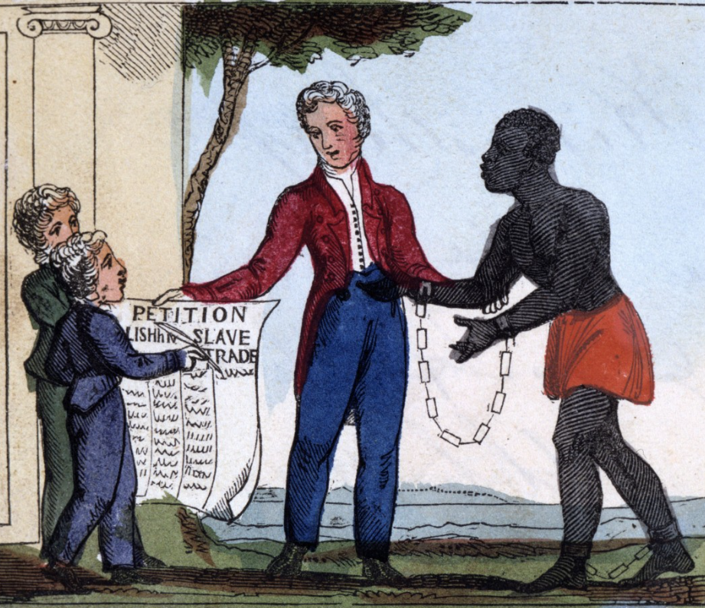 Text links
