**BIG IDEAS**

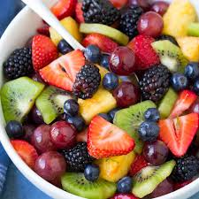

**What could be in our fruit salad?**

A fruit salad is a delicious bowl of fruit chopped and mixed together. It is a healthy snack or desert.

Vocabulary that we will use:

Hygiene – keeping hands and surfaces clean and bacteria free.

Fruit – bananas, apples, kiwis, strawberries etc.

Cut – to use a knife to chop, dice or cut fruit into slices and shapes.

Ingredients – items you add into a fruit salad.



