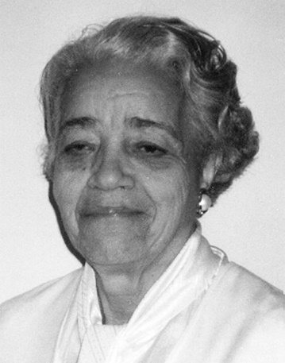
DOROTHY VAUGHAN

Dorothy Vaughan was an American mathematician. She made important contributions to the early years of the United States space program. Vaughan also served as the first African American manager at what would become the National Aeronautics and Space Administration (NASA).

EARLY LIFE
Dorothy Johnson was born on September 20, 1910, in Kansas City, Missouri. Her family moved to West Virginia in 1917. In 1929 she graduated with a degree in mathematics from Wilberforce University in Xenia, Ohio. She worked as a math teacher in Virginia and married Howard S. Vaughan, Jr.

CAREER
In December 1943 Vaughan began work at the West Area Computing unit, part of the National Advisory Committee for Aeronautics (NACA). The West Area Computing unit was a group of African American female mathematicians. These women were known as the West Computers because they made computations, or mathematical calculations. They provided data that was essential to the success of the U.S. space program.
The West Computers were segregated from white employees. They were forced to use separate bathrooms and dining facilities. Despite these conditions, Vaughan was promoted to lead the West Computers in 1949. She became NACA’s first Black supervisor and one of the few female supervisors.
Vaughan served in that position until 1958, when NACA became NASA and segregated facilities were closed. Vaughan and many other West Computers then joined the NASA Analysis and Computation Division, a group made up of men and women of all races. Vaughan became an expert FORTRAN programmer. (FORTRAN is a computer programming language that is used for scientific and algebraic applications.) She retired from NASA in 1971.
Vaughan died on November 10, 2008, in Hampton, Virginia. She and other West Computers—Katherine Johnson and Mary Jackson—were the inspiration for Margot Lee Shetterly’s book Hidden Figures: The American Dream and the Untold Story of the Black Women Mathematicians Who Helped Win the Space Race. The book was made into a film, and both the book and the film appeared in 2016.

