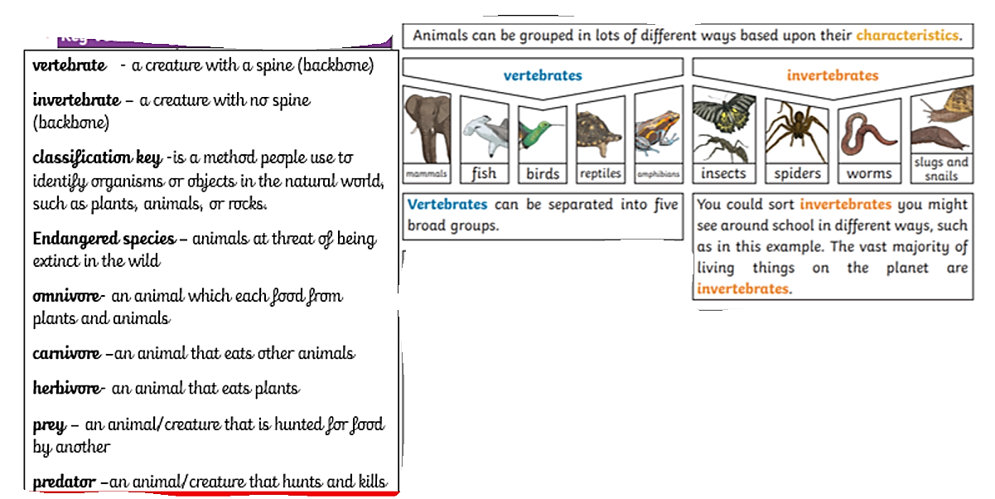
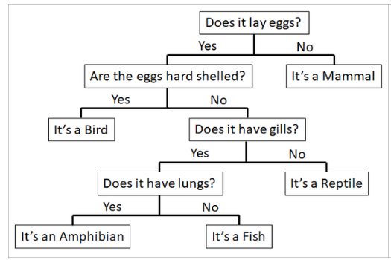
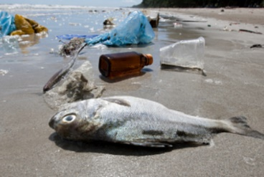
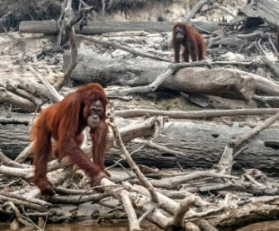
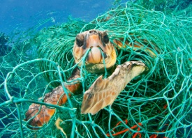
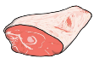
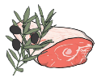

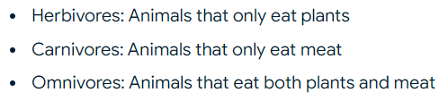
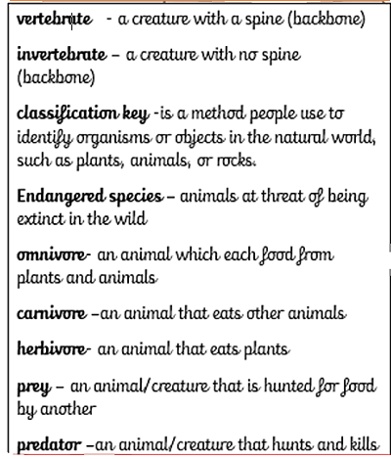
Big Ideas
How are living things grouped ?
A classification key is a set of questions about the features of a living thing that can be used to identify it.
Animals can also be grouped based on their feeding patterns ( what they eat )
Humans are now responsible for causing changes in the environment that hurt animals and plant species. We take up more space on Earth for our homes and cities. We pollute habitats. We illegally hunt and kill animals.
MR FAB is an easy way to remember the 5 groups of vertebrates !
Mammals Reptiles Fish Amphibians Birds

