
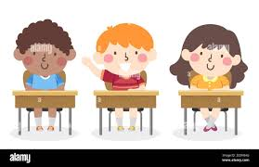
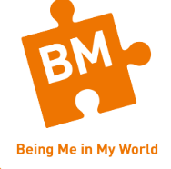



BIG PICTURE
Vocabulary we will use:
safe
special
calm
belonging
rights
responsibilities
class
charter
Questions we will investigate on our learning journey:
- Do I feel safe and special in my class?
- Do I know that I belong to my class?
- Can I make my class a safe space for everybody to learn?
- Do I recognise how it feels to be proud of an achievement?
- Can I recognise the range of feelings that I face when I get a consequence?
- Do I understand my choices when following the LEARNING CHARTER?
Skills we will use on our learning journey:

Listening
Sharing
Reflecting
Explaining
Understanding

Question I would like to ask:

Being Me in My World

