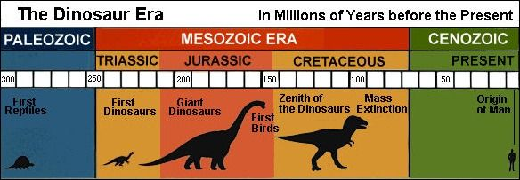Big Ideas

