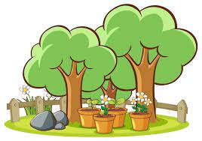

Big Picture

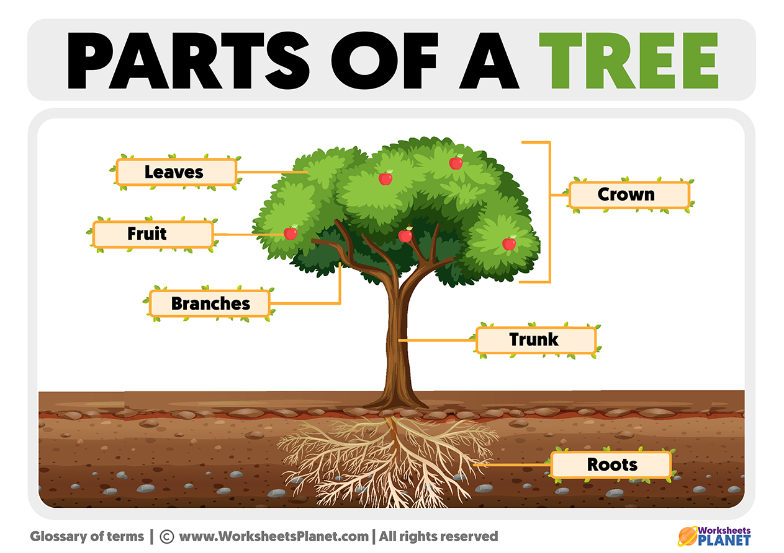

**What do plants and trees need to grow healthily??**

**:Skills we will use: to know that we can ask questions about the world and that when we observe the world to answer these questions, this is science.**

**Talk partners, research, grouping and classifying, observing, drawing, discussing, writing.**

**Questions we will explore…**

* What are the main parts of plants or trees, including roots, stem, leaf and petal, called?
* How do we know that plants and trees need light, water and soil?
* How can we find out how old a tree is?
* What are the names of some trees in our locality?

**Vocabulary we will use…**

**trunk, crown, blossom, bulbs woodland, stem**

**Question I would like to ask…**

