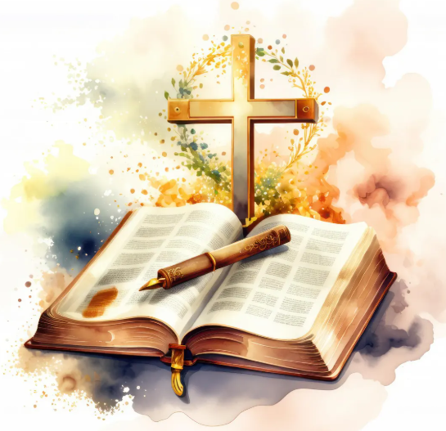  Old Testament | The Old Testament contains stories and writings from before the birth of Jesus. The first five books of the Old Testament (the books of Moses) are also sacred texts to Jewish people.
New Testament | The New Testament is about the life and teachings of Jesus and his followers. The final book in the Bible is a prophecy about how Jesus will return one day.
Key vocabulary | Definition
sacred | Very holy and special.
Christians | People who follow the religion of Christianity.
revelation | The Christian belief that God reveals himself to people through words or actions.
Bible | The holy book followed by Christians
psalms | Poems and songs recorded in the Bible.
parables | A story told by Jesus, to teach a particular lesson.
proverbs | Wise sayings recorded in the Bible.
How and why do Christians read the Bible?
Big ideas
The Bible is sacred to Christians because they believe it is God’s special message to people. It teaches them how to live, tells important stories about their faith, and helps guide their choices. Christians use the Bible in worship, prayer, and everyday life, which makes it a holy and treasured book.

Old Testament
- The earliest parts were written around 1400–1000 BC.
- Many books were written between 950–500 BC.
- The Old Testament was fully completed by around 100 AD.
- Old Testament: 39 books

New Testament
- Written much later, between 50–100 AD.
- • New Testament: 27 books
- • Whole Bible: 66 books

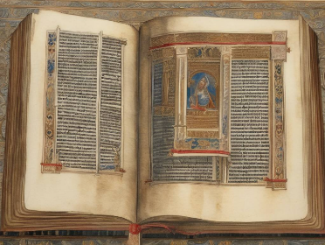

The first printed Bible was the Gutenberg Bible, completed around 1455 AD.
Johannes Gutenberg used movable metal type, which was a brand-new invention in Europe at the time. This made it possible to print books much faster than copying them by hand, and the Gutenberg Bible became the first major book ever printed.

