* How can you use maps and a globe to locate the Equator, the North Pole and the South Pole?
* How have people adapted to live in a very hot climate?
* How have people adapted to live in a very cold climate?
* Which animals will we find living naturally in very hot or very cold regions?

**How can we identify weather patterns?**

**Big picture**

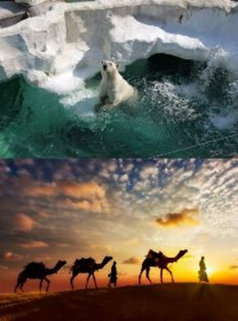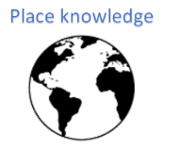

**Skills we will use:**

map skills comparing

date collecting

reading maps identifying

discussing questioning

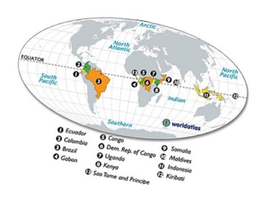 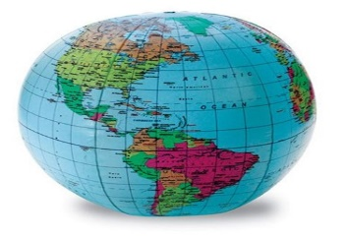 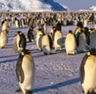

**Questions I would like to ask:**

**Vocabulary we will use:**

North Pole Equator

South Pole camouflage desert

glacier