Big Ideas- Brazil
Exciting books:
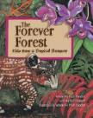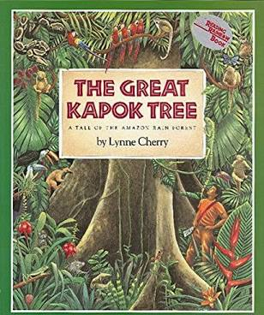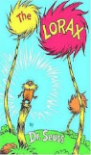
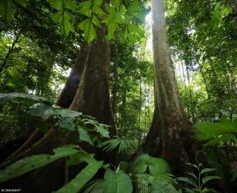

canopy | The canopy, which may be over 30 m above the ground, is made up of the overlapping branches and leaves of rainforest trees.
emergent layer | The emergent layer is the name given to the tops of trees that poke up above the rainforest canopy.
understory | The understory layer is a tangle of shrubs, young trees, saplings, palms and vines. It is hot and damp here and the air is very still.
deforestation | When forests are cut down and the area is permanently cleared for another use.
endangered | An endangered species is a species which has been categorized as very likely to become extinct.
indigenous | Indigenous people or things belong to the country in which they are found
biomes | Biomes are distinct biological communities that have formed in response to a shared physical climate.
temperate | Relating to a region or climate characterized by mild temperatures.
extinction | The extinction of a species of animal or plant is the death of all its remaining living members.
destruction | The act of destroying something.
biodiversity | Variety of plant and animal life in a particular habitat, a high level of which is usually considered to be important and desirable.
Important facts to know:
- Only around 6% of the Earth’s land surface is rainforest – but about half of all animal and plant species live there.
- It can take ten minutes for a falling raindrop to travel from a rainforest’s thick canopy to the floor.
- The Amazon rainforest in South America is so big that if it were a country, it would be the ninth biggest in the world.

