|  |  |
| --- | --- |
| vascular | These are plants which have a well-developed system of transporting water, food and minerals |
| nonvascular | These are plants which DO NOT have a well-developed system of transporting water, food and minerals. |
| gymnosperm | Actually means ‘naked seed’ because these plants reproduce using cones instead of seeds. Gymnosperms are easily identifiable thanks to their wood and green needle-like or scale-like foliage. |
| Flowering plants ( also called angiosperms) | All flowering plants share the characteristic of having seeds enclosed / protected/ hidden within their fruit.  This group of plants includes a vast range of species, including trees, herbs, shrubs, bulbs, epiphytes, and aquatic plants. |
| adaptations | This is **when a species develops special features to improve its chances of survival.**  Plants need to adapt for three main reasons:  To survive harsh environmental conditions such as the climate. To protect themselves against predators. To be more successful when living alongside competitors. This includes fighting for space, water, or nutrients.  **Prior knowledge** – living creatures can be grouped in different ways. They will share certain characteristics in common. Eg vertebrates or non- vertebrates.  There are 5 groups of vertebrates ( MR FAB )  Living things can also be grouped based upon their feeding patterns ( carnivore, herbivore or omnivore) |

**All living things belong to one of the 5 kingdoms**.

Within each kingdom, there are many other groups which share certain characteristics in common.

Are all plants the same ?

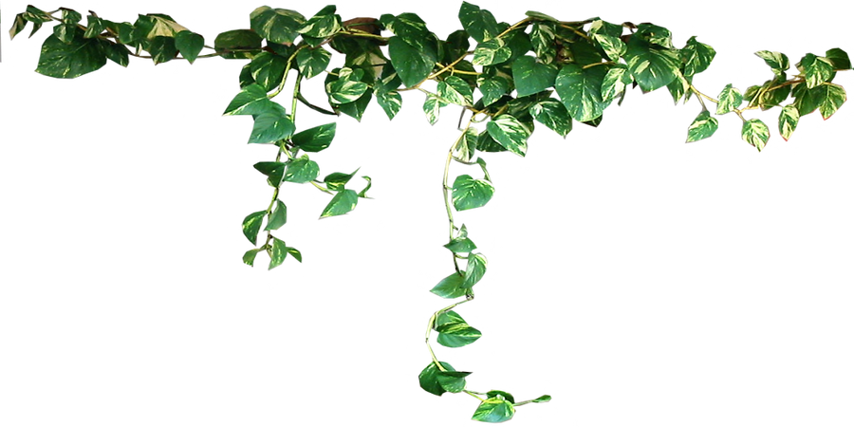



**Big ideas**

**Produces flowers**

**Does not produce flowers**

**Has a root system**

**short**

**tall**

**Has no stem**

**Produces seeds**

**Does not produce seeds**

**Are all plants the same ?**