## How do our celebrations reflect the true meaning of Christmas?

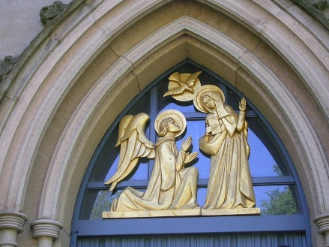

**Questions I would like to explore?**

* Where in the Bible is the Christmas story?
* How does the nativity story/birth of Jesus fit into God’s Big Story?
* Why are the stories in Matthew and Luke similar/different?
* How do our celebrations reflect the true meaning of Christmas?
* Where do the ideas of including a donkey and a stable in the story come from?

[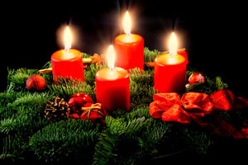](http://www.google.co.uk/url?sa=i&rct=j&q=&esrc=s&source=images&cd=&cad=rja&uact=8&ved=0CAcQjRxqFQoTCJSjlcDhgckCFYNrFAodVPwNnA&url=http://antonian.tv/category/kulture/page/14/&bvm=bv.106923889,d.ZWU&psig=AFQjCNGb-jB0Mo6VkkIJkumYKCzqaymFGw&ust=1447104080938232)

*Vocabulary we will use:*

Saviour, Messiah, Gospel, Matthew, Luke, nativity, Herod, incarnation, and salvation.

*Values:*

* Hope
* Humility

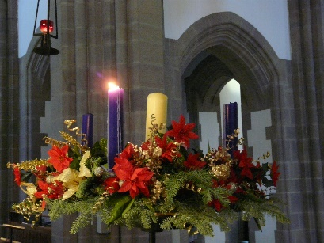 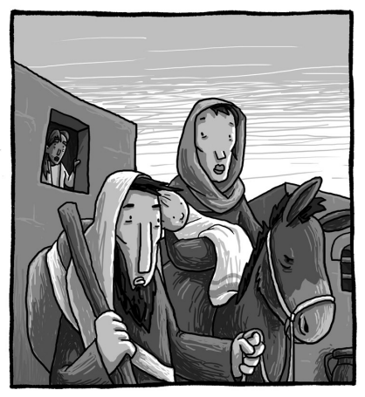

*Skills I will use:*

* Enquire
* Synthesise
* Analyse
* Reflect
* Evaluate
* Apply

Questions I would like to ask...